Test Case/s to be automated

Contents

Pay Billing 1

Pre-requisites 1

Test setup: 1

Test case 1: GIVEN active customer WHEN submit THEN customer id displayed correctly 2

Test case 2: GIVEN active customer WHEN submit THEN customer name displayed correctly 3

Test case 3: GIVEN active customer WHEN submit THEN tariff plan amount displayed correctly 4

Test case 5: GIVEN active customer WHEN submit THEN total bill amount displayed correctly 5

Check point 6

# Pay Billing

## Pre-requisites

Ensure you are working and pushing to your own branch

## Test setup:

Navigate to <http://demo.guru99.com/telecom/index.html>

Select Pay Billing

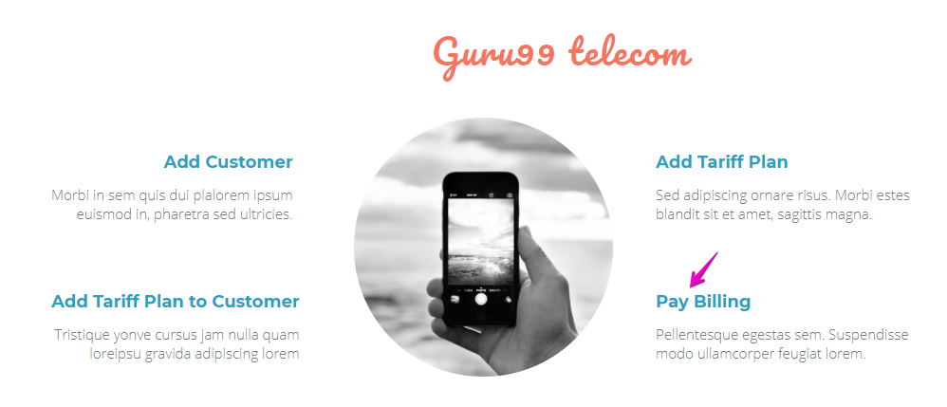

Assert that the Heading is Guru 99 Telcom and Pay Billing

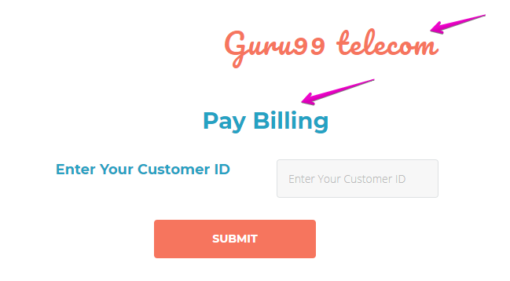

## Test case 1: GIVEN active customer WHEN submit THEN customer id displayed correctly

Create a customer who has done a credit check



Enter the customer id and submit

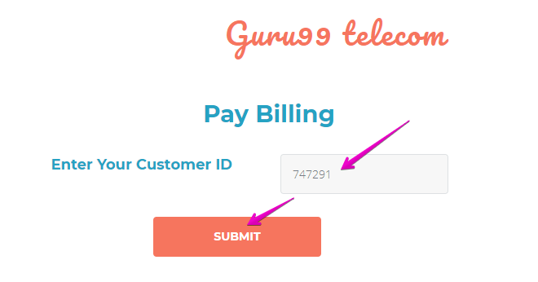

Expected Result:

Customer id displayed correctly

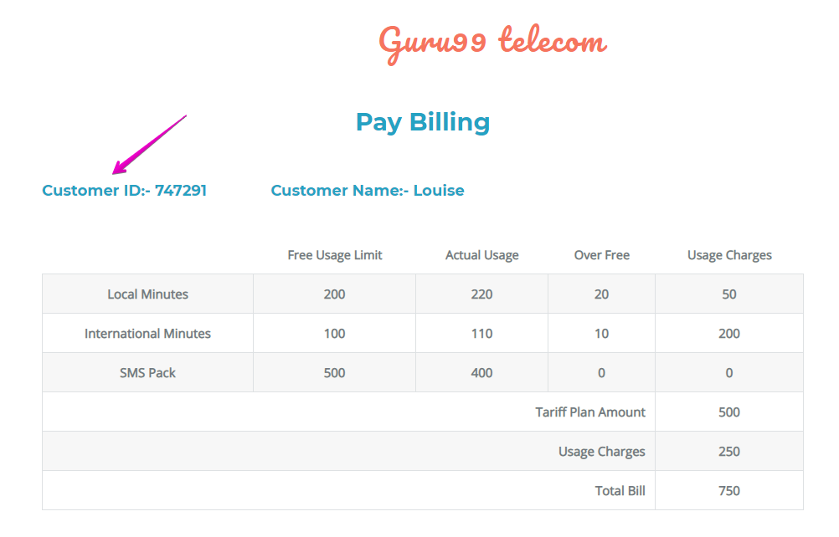

## Test case 2: GIVEN active customer WHEN submit THEN customer name displayed correctly

Create a customer who has done a credit check



Enter the customer id and submit



Expected Result:

Customer name displayed correctly

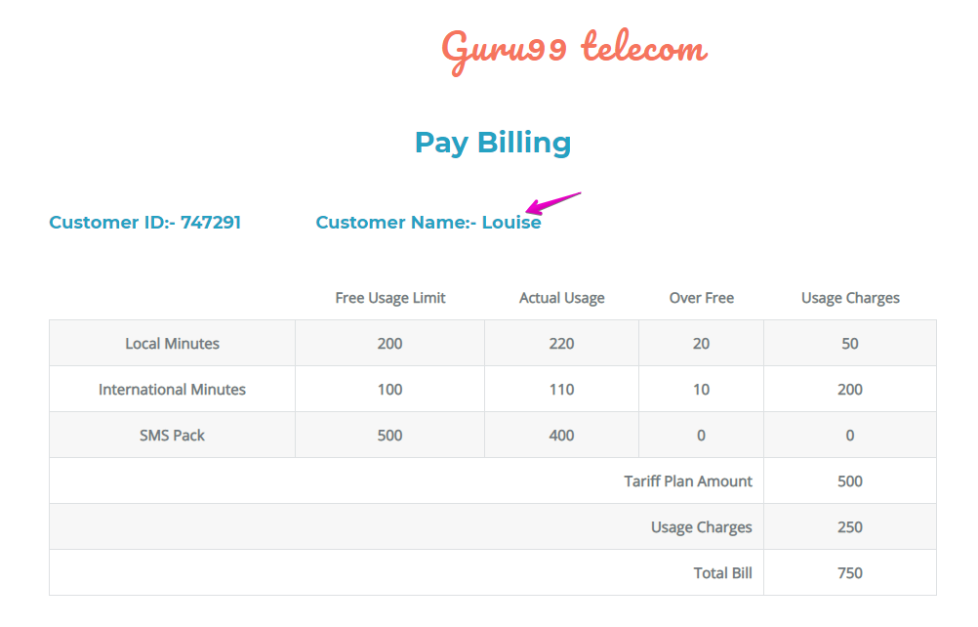

## Test case 3: GIVEN active customer WHEN submit THEN tariff plan amount displayed correctly

Create a customer who has done a credit check



Enter the customer id and submit



Expected Result:

Usage charge value is equal to local min and int min and sms pack usage charge amount

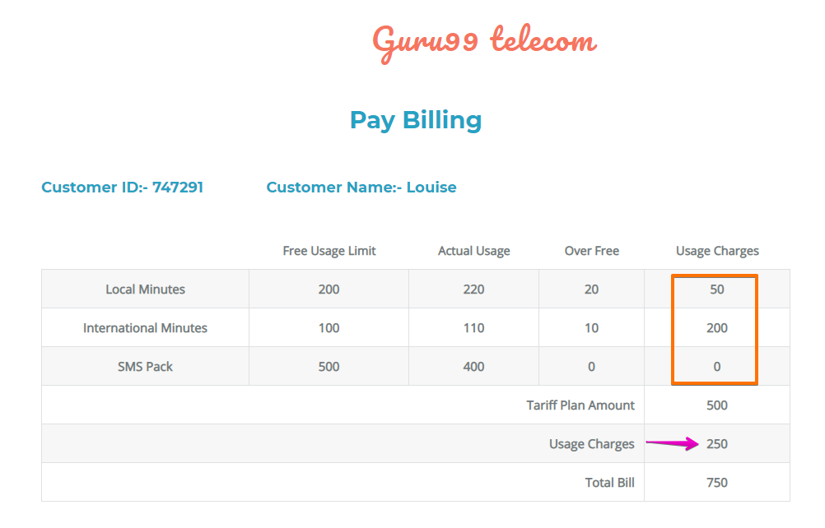

## Test case 5: GIVEN active customer WHEN submit THEN total bill amount displayed correctly

Create a customer who has done a credit check



Enter the customer id and submit



T

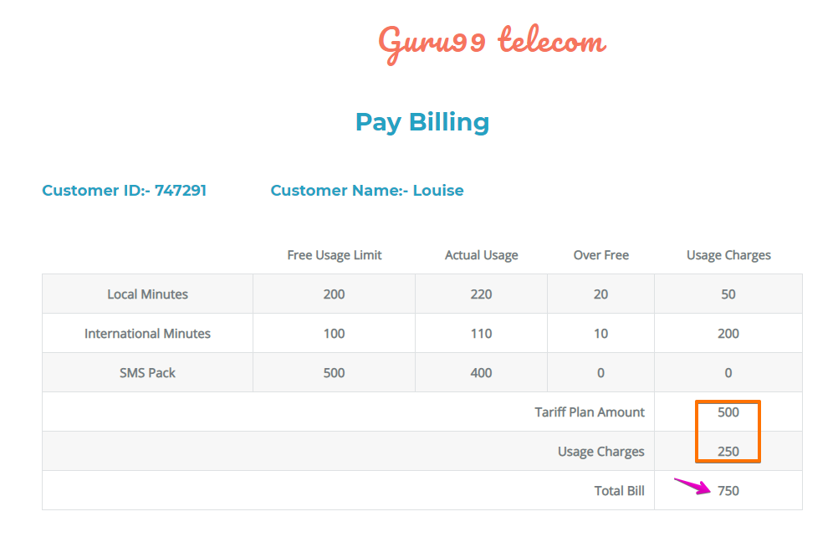

## Check point

Ask a friend to look at your work or do a demo